FOOD MANAGEMENT SYSTEM

Use-Case Specification: Login

Version <1.0>

Revision History

|  |  |  |  |
| --- | --- | --- | --- |
| **Date** | **Version** | **Description** | **Author** |
| <7/12/2020> | <1.0> | <details> | <Nguyen Thu Trang> |

Table of Contents

1. Use-Case Name 4

1.1 Brief Description 4

2. Flow of Events 4

2.1 Basic flow 4

2.2 Alternative flow 4

2.2.1 <First Alternative flow> 4

2.2.1 <Second Alternative flow> 4

3. Special Requirement 5

3.1 <First Special Requirement> 5

4. Preconditions 5

4.1 <Precondition One> 5

5. Posstcondition 4

5.1 <Postcondition One> 5

6. Extension Points 5

6.1 < Name of Extension Points> 5

Use-Case Specification: Login

1. **Login**
   1. **Brief Description**

This use-case defines the steps of logging in to the system as a admin. Admin can easily login by entering his username and password.

* 1. **Actor**

Customer.

1. **Flow of Events**
   1. **Basic Flow**

Customer clicks the login button on restaurant’s home page. After that a login form appears, customer fills his username and password in that login form. Then, clicks the login button. Eventually, the system redirects to the TAT Restaurant home page.

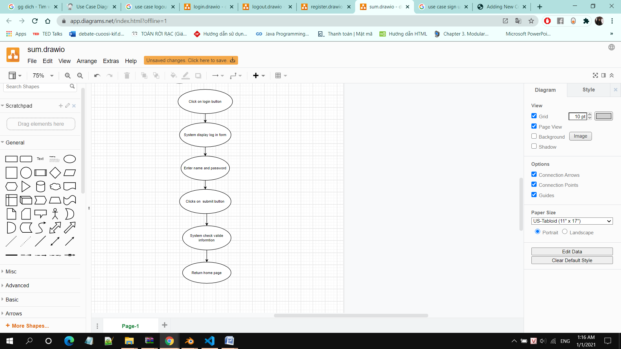

1. **Special Requirements**
   1. **Valid Username and Password**

Admin must enter valid username and password.

1. **Forgot Username and/or Password**

The system should have a function to support the users in case of forgetting username

and/or password.

1. **Preconditions**

Admin must already have a TAT restaurant account.

1. **Postconditions**

Admin wait for the system checking his/her account.

1. **Extension Points**

Personal information security should be considered.